Creating Yearly Tile Reports in Success Factors
Overall Performance Rating Distribution

Each year a new set of tile reports need to be created with the new year’s templates (instead of just updating the old report tile) because the system remembers what template was attached to the report tile the first time a user clicks on it. That prior use filter information does NOT change unless the user goes into the filter and manually updates the attached template in the old report tile’s filter. Creating a new tile each year with the correct template avoids the whole issue as it is a ‘new’ object.
(Example: Lauren Peters saw only 2017 data in Feb 2020 even though the tile report had been changed to point to new templates twice in Feb 2019 and Feb 2020.)

Go to Admin Center > Reporting and Analytics > Manage Dashboards. Click on the “Manage Standard Dashboards and YouCalc Files“ link.

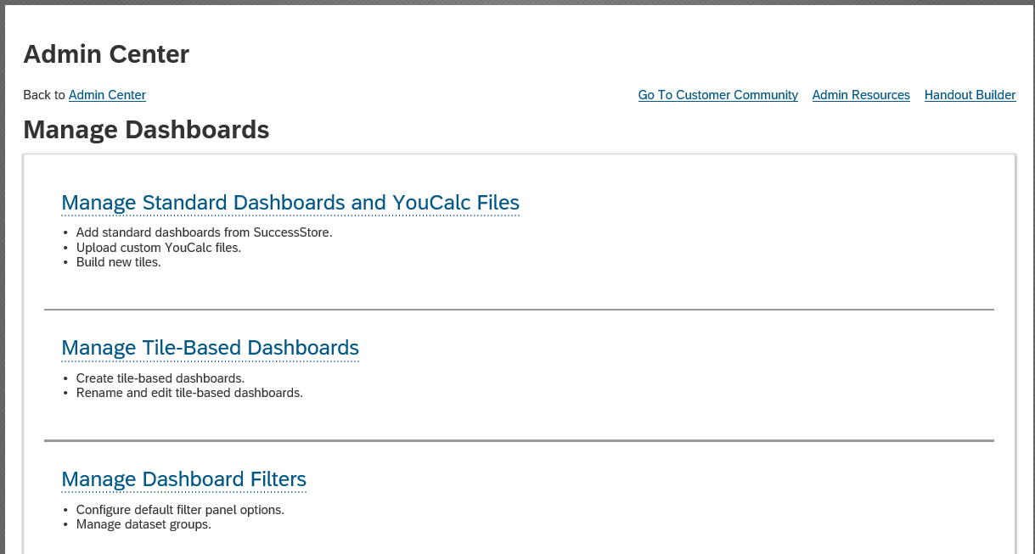

When you get to this page, click on the green plus circle icon in front of “Add From SuccessStore”.
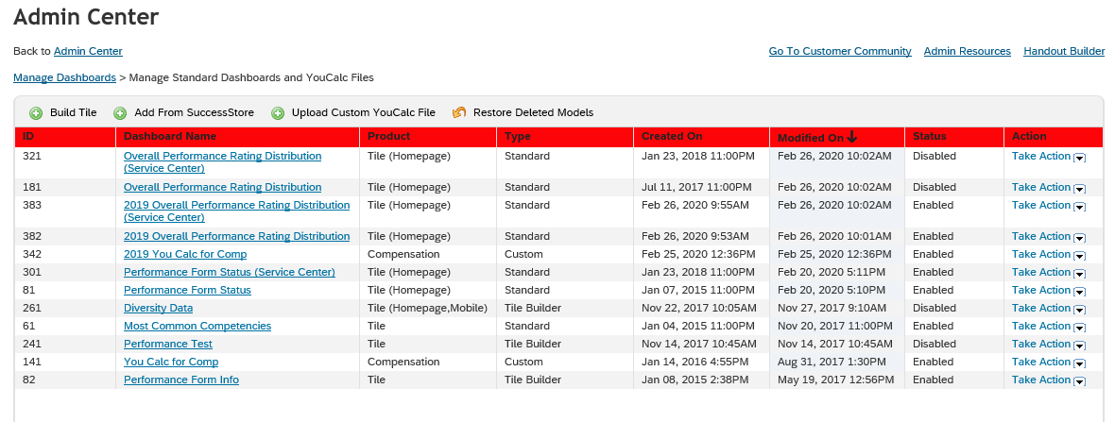

Success Factors has many ready to use report tile templates. The Dashboard Name we want is called “Overall Performance Rating Distribution”. Scroll through the pages until you get to it.
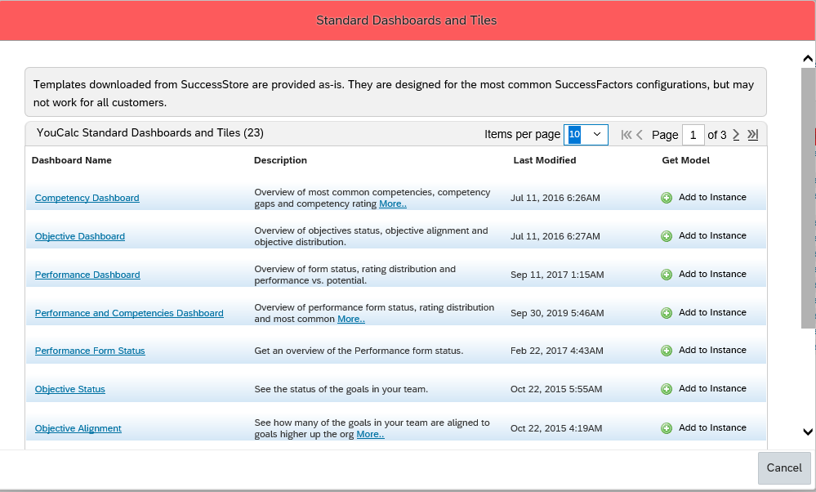

In the “Get Model” column (far right side), click the plus icon to add this template to whichever instance of Success Factors you are working in.
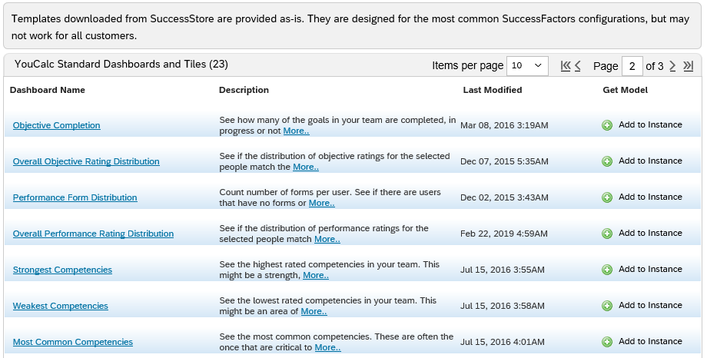

Since the template’s original name already exists in our Success Factors system, use this error page to name the new year’s tile with the appropriate year, then click OK.
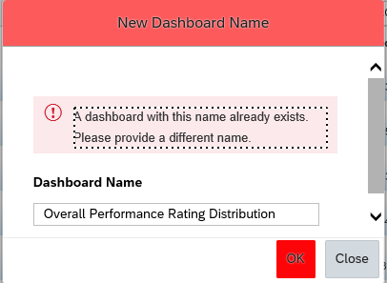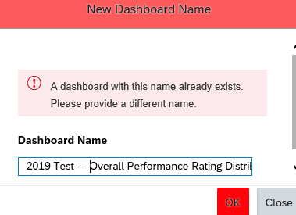
The system will bring you to the report attached to this tile.
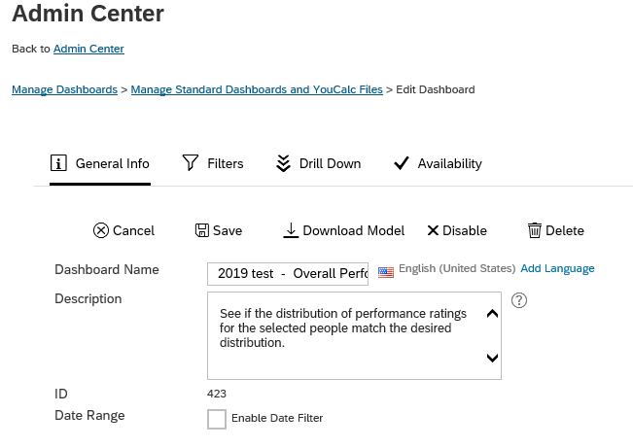

Click on Filters. The two red circled areas must be changed. 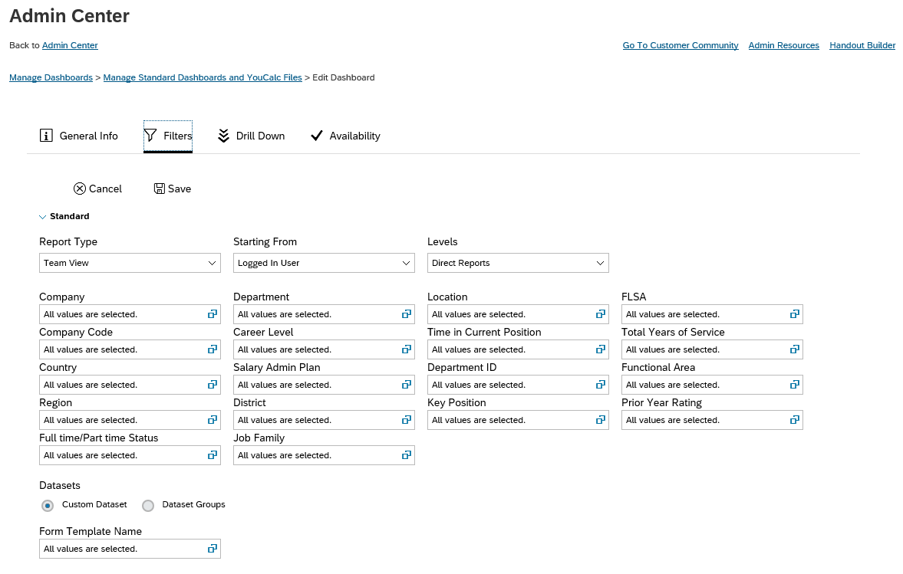

Change “Report Type” to Team View of Logged in User for ALL Levels.
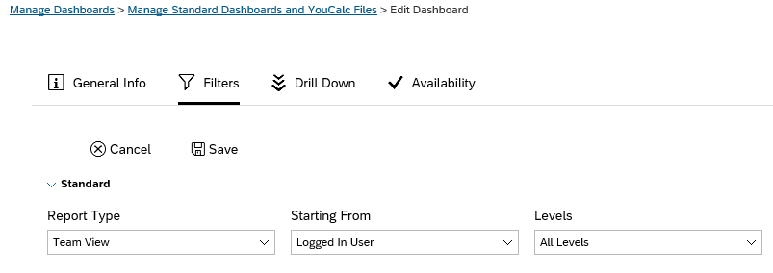
Click the filter icon for “Form Template Name” in the Datasets section.
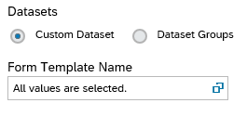

On this page, click on the “By My Selection” radio button, then select the correct template to be attached to this year’s report tile. Since the tile we just created is for the NON-Service Center associates, we must choose the NON-Service Center template.

Click DONE to save the dataset template change.
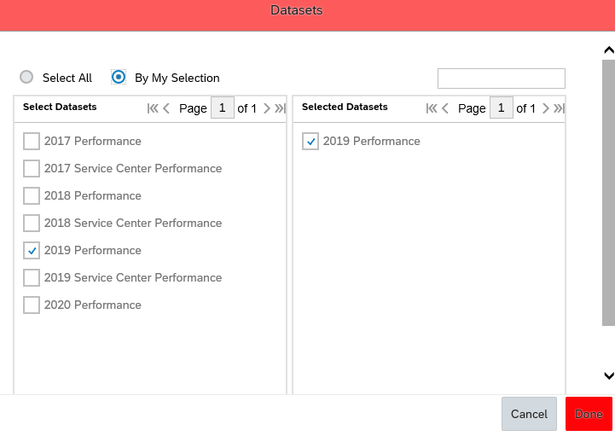

Go to “Drill Down” to adjust which fields are displayed in the report and in which order they appear. Match the fields and field order to the old report to make it easier for our business partners. Clicking the pencil icon opens up the datasets so you can pick new/different fields.
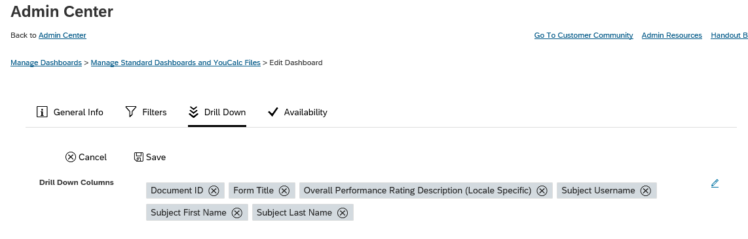
Note: You must add fields in the order you want them to appear. SF does not let us drag columns!
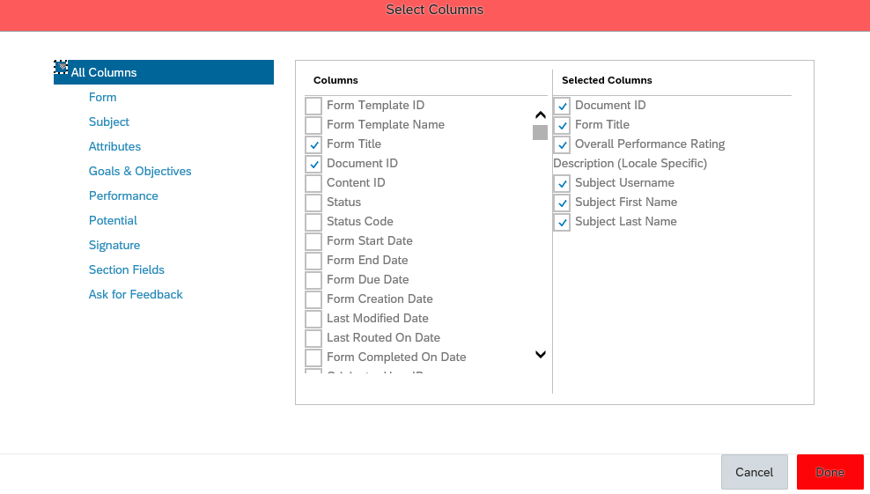

Click DONE to save any column changes you made.

Go to Availability and check the Homepage box.
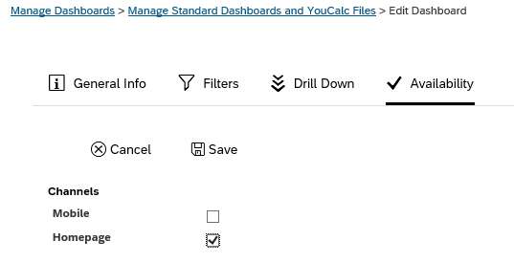

Click the SAVE icon to save the report changes. The new tile report is automatically enabled and can be seen in Manage Dashboards > Manage Standard Dashboards and YouCalc Files.
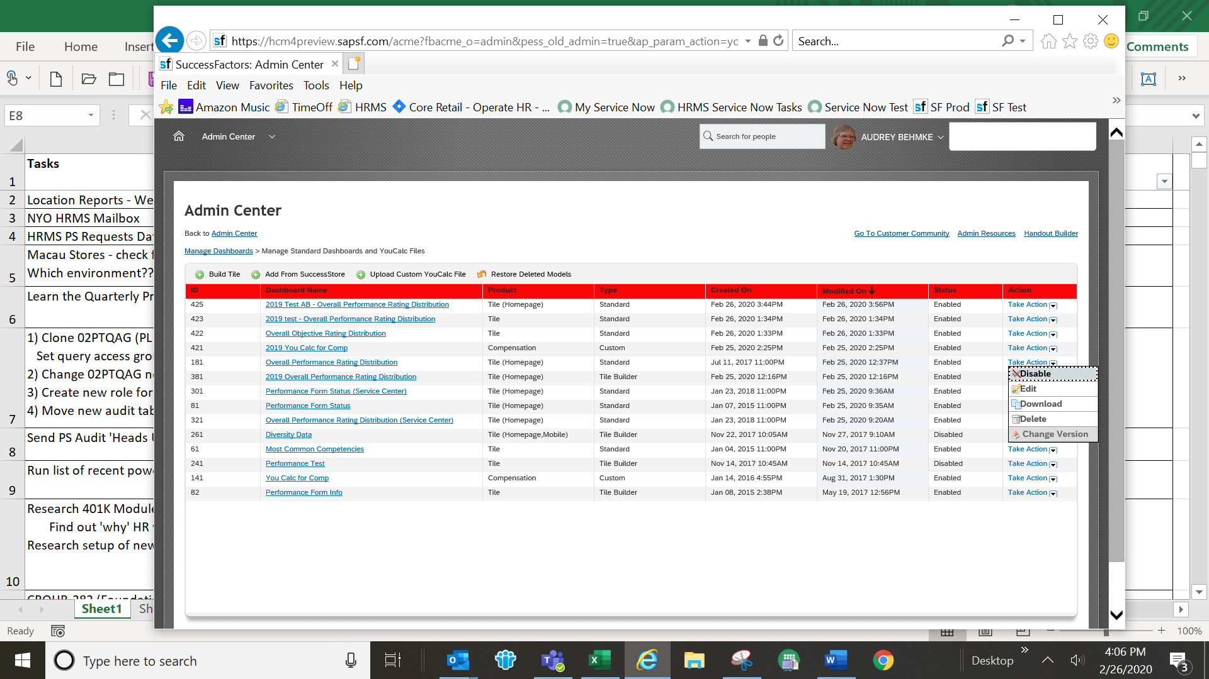

Disable the old tiles by clicking the ‘Take Action’ dropdown arrow and selecting “Disable”. This prevents users from accidentally clicking on the old tile and getting old data.


Go to Admin Center > Company Settings > Manage Home Page
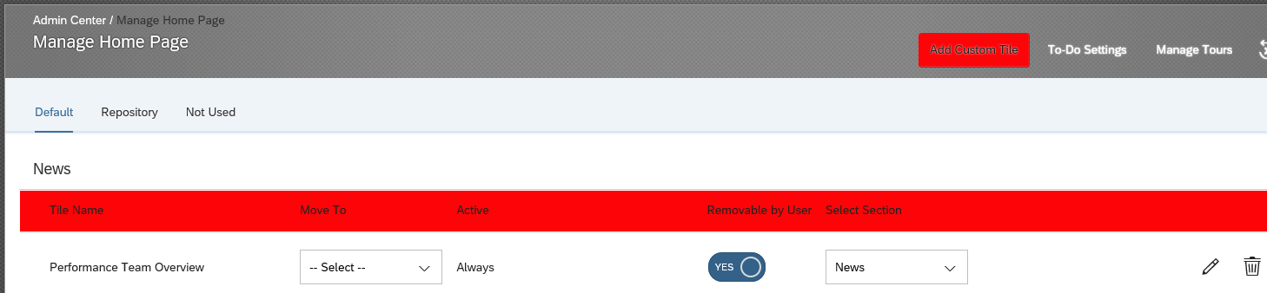

The new tile report you created will have been placed at the bottom of the “My Team” section. Scroll down until you find it and choose “News” from the drop-down list in the Select Section column.
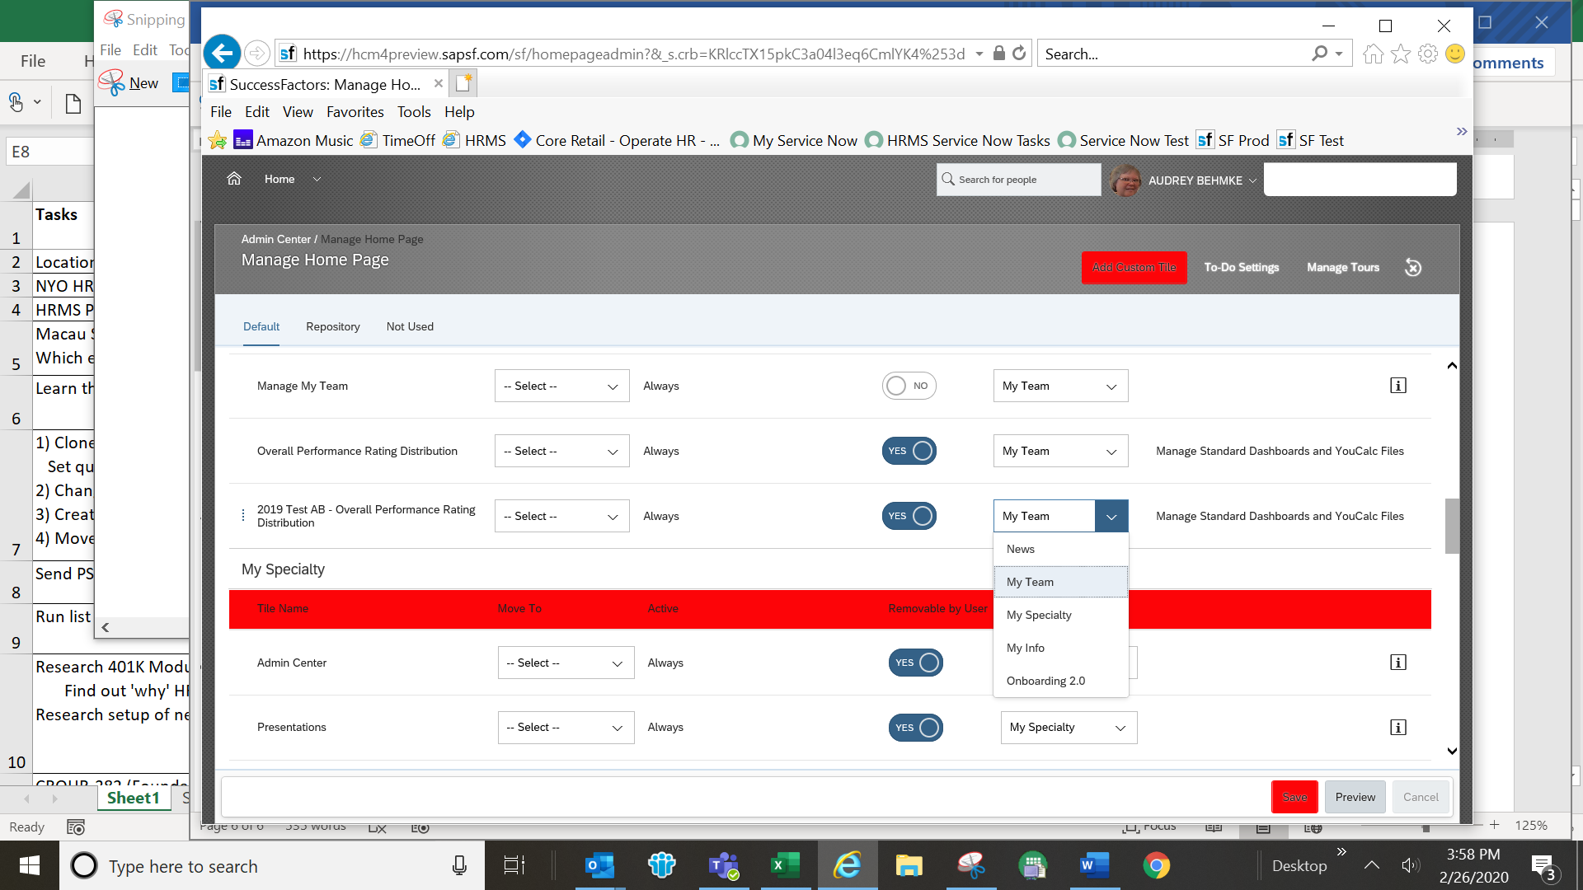

It will be placed at the bottom of the “News” section. To move it up, click on the 3 dots icon on the left and drag the new report where the old one was.

